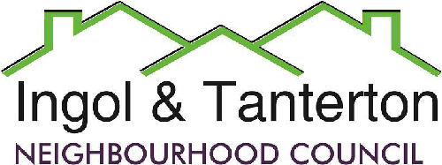

Gill Mason - Clerk and RFO

Email: [ingoltantertonnc@hotmail.co.uk](mailto:ingoltantertonnc@hotmail.co.uk)

**Agenda**

**A meeting of the Ingol and Tanterton Neighbourhood Council Tanterton Village Centre Management Committee will be held on Monday 9th December 2024**

**at 7.15pm at the Tanterton Village Centre.**

**Open forum**

1.To receive apologies.

2.To consider the proposal from the TVC trustees regarding the management takeover and to review the NALC solicitor’s advisory notes.

3.Date and time of next meeting.

Press and public are welcome to attend.